MangaDex

🎓 Definition
# Source: ScreenShots Source: Provided by: [Persons Table -> ID Column: 1, Name_En Column: Motasem Essam] -> Tool: [Lightshot Program] -> From [Site: https://mangadex.org/] on [10/28/2025]
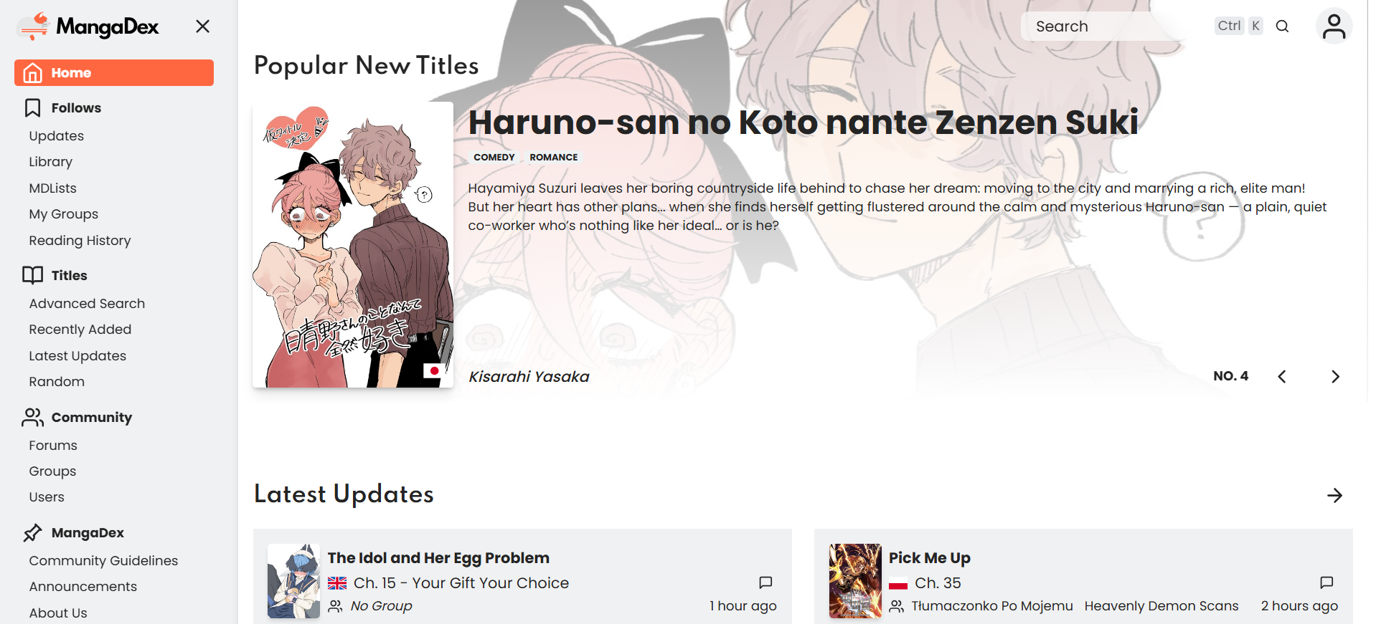
# Source: AI Source: Provided by: [Data Path: Persons Table -> ID Column: 1, Name_En Column: Motasem Essam] -> From: [ChatGPT] on [10/28/2025]
MangaDex is a popular online manga reading platform that hosts and shares user-uploaded manga chapters in multiple languages.
It’s one of the largest community-driven manga aggregators, where readers can browse, read, and discuss manga, manhwa (Korean comics), and manhua (Chinese comics).

🔹 Main Features
# Source: AI Source: Provided by: [Data Path: Persons Table -> ID Column: 1, Name_En Column: Motasem Essam] -> From: [ChatGPT] on [10/28/2025]
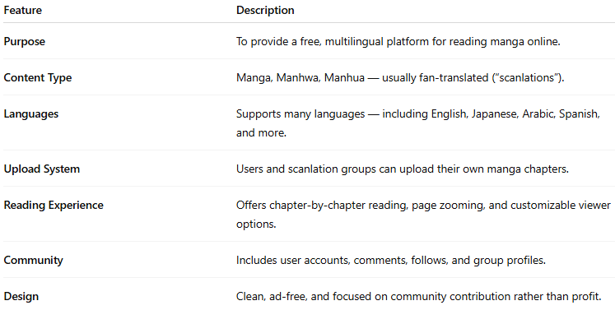
Feature | Description
Purpose | To provide a free, multilingual platform for reading manga online.
Content Type | Manga, Manhwa, Manhua — usually fan-translated (“scanlations”).
Languages | Supports many languages — including English, Japanese, Arabic, Spanish, and more.
Upload System | Users and scanlation groups can upload their own manga chapters.
Reading Experience | Offers chapter-by-chapter reading, page zooming, and customizable viewer options.
Community | Includes user accounts, comments, follows, and group profiles.
Design | Clean, ad-free, and focused on community contribution rather than profit.

⚙️ Technical / Site Type
# Source: AI Source: Provided by: [Data Path: Persons Table -> ID Column: 1, Name_En Column: Motasem Essam] -> From: [ChatGPT] on [10/28/2025]
- Category: Manga Aggregator / Digital Reading Platform
- Type: Non-commercial, community-based website
- Domain: https://mangadex.org

⚠️ Important Note
# Source: AI Source: Provided by: [Data Path: Persons Table -> ID Column: 1, Name_En Column: Motasem Essam] -> From: [ChatGPT] on [10/28/2025]
- MangaDex itself is not an official publisher — it allows users to upload and share fan translations of manga.
- Some uploaded works might not have official distribution rights, so content legality varies by country and publisher agreements.

📖 In Simple Terms
# Source: AI Source: Provided by: [Data Path: Persons Table -> ID Column: 1, Name_En Column: Motasem Essam] -> From: [ChatGPT] on [10/28/2025]
MangaDex is a community website where people can read and share manga online in many languages — similar to a library of fan-translated comics.

